

**PENTECOST**

He Will Pour Out His Spirit on All Flesh

**WELCOME**

Welcome to worship at Peace. We’re so glad you’re here!

Fifty days after the Passover, God’s Old Testament people celebrated Pentecost (Greek for “fifty”). Pentecost commemorated the gathering of the harvest and was also used to remember the giving of the Law on Mt. Sinai, the start of the Church of Israel. Christ chose Pentecost to be the birthday of his New Testament Church too. By pouring out his Holy Spirit, Christ empowered the Church to gather in the great harvest of souls won by the Son.

Pentecost is the third great festival of the Church, along with the Nativity and the Resurrection. The early church fathers mention the Festival of Pentecost often enough to lead many to believe it was celebrated annually already at the time of the apostles. Pentecost closes the fifty-day period after Easter and ends the festival half of the church year. The Church dresses in red this day to remind us of the tongues of fire that marked the Spirit’s gift, as well as the blood of the martyrs

which was the seed of the Church.

Today is also Father’s Day! Not that our thankfulness is limited only to this day, but today we are especially thankful to God for providing Christians fathers who loving lead, model, serve and care for their families in a way that models Christ and makes Him the priority!

Lord bless our worship today!

**IMPORTANT NOTES FOR TODAY’S WORSHIP**

Please take time to fill out the connection cards (located on the back of the chairs). You can drop them off in the box that looks like a church outside of the sanctuary.

The service in its entirety will be printed in your bulletin and projected up on the screens.

You can worship along with this service in the church parking lot by tuning into FM 103.5.

Copyright information for worship:

*Recording and music in today’s service is used with permission under Onelicense.net, license #A- 711675, and CCLI, license1159761.*

*Setting 2*

*Scripture references, unless stated otherwise, are from the Evangelical Heritage Version*

*Software distributed in partnership with Northwestern Publishing House.*

*Created by Christian Worship: Service Builder © 2022 Concordia Publishing House.*

Come, Holy Ghost, Creator Blest CW 586 sts. 1–5

1 Come, Holy Ghost, Creator blest,  
and make our hearts your place of rest;  
come with your grace and heav’nly aid,  
and fill the hearts which you have made.

2 To you, the Counselor, we cry,  
to you, the gift of God most high,  
the fount of life, the fire of love,  
the soul’s anointing from above.

3 In you, with graces sevenfold,  
we God’s almighty hand behold  
while you with tongues of fire proclaim  
to all the world his holy name.

4 Your light to ev’ry thought impart,  
and shed your love in ev’ry heart;  
the weakness of our mortal state  
with deathless might invigorate.

5 Drive far away our wily foe,  
and your abiding peace bestow;  
with you as our protecting guide,  
no evil can with us abide.

Stand

In the name of the Father and of the 🕇 Son and of the Holy Spirit.

**Amen.**

Come, Holy Ghost, Creator Blest CW 586 st. 6

6 Teach us to know the Father, Son,  
and you, from both, as Three in One  
that we your name may ever bless  
and in our lives the truth confess.

Pentecost Dialogue

In the beginning God created the heavens and the earth. Now the earth was formless and empty, and the Spirit of God was hovering over the waters.

**The Spirit of God has made me; the breath of the Almighty gives me life.**

Where can I go from your Spirit? Where can I flee from your presence?

**If I go up to the heavens, you are there; if I make my bed in the depths, you are there.**

The Lord said, “My Spirit will not contend with man forever.”

**O Lord, do not rebuke me in your anger or discipline me in your wrath.**

Be merciful to me, Lord, for I am faint; O Lord, heal me, for my bones are in agony.

**Turn, O Lord, and deliver me; save me because of your unfailing love.**

Jesus said to his disciples, “Receive the Holy Spirit. If you forgive anyone his sins, they are forgiven; if you do not forgive them, they are not forgiven.”

**No one can enter the kingdom of God unless he is born of water and the Spirit. Flesh gives birth to flesh, but the Spirit gives birth to spirit.**

The Spirit of the Sovereign Lord is on me, because the Lord has anointed me to preach good news to the poor.

**There is now no condemnation for those who are in Christ Jesus, because through Christ Jesus the law of the Spirit of life set me free from the law of sin and death.**

Now the Lord is the Spirit, and where the Spirit of the Lord is, there is freedom.

**Come, Holy Spirit! Fill the hearts of your faithful people, and kindle in us the fire of your love. Alleluia!**

Come, Holy Ghost, Creator Blest CW 586 st. 7

7 Praise we the Father and the Son  
and Holy Spirit, with them One,  
and may the Son on us bestow  
the gifts that from the Spirit flow!

Text: tr. Edward Caswall, 1814–1878, alt.; attr. Rhabanus Maurus, 776–856  
Text: Public domain

Prayer of the Day

The Lord be with you.

**And also with you.**

Let us pray. Holy Spirit, God and Lord, come to us this joyful day with your sevenfold gift of grace. Rekindle in our hearts the holy fire of your love that in a true and living faith we may tell abroad the glory of our Savior, Jesus Christ, who lives and reigns with you and the Father, one God, now and forever.

**Amen.**

**Children’s Object Lesson**

*At this time, all children are invited to come up to the front for a short object lesson taught by Pastor that seeks to bring the truth of God’s Word for the day to them. Parents, if you or your children would be more comfortable with you coming up to sit with them, you are welcome to do so.*

Be seated

# THE WORD

First Reading Acts 2:1–21

*In the Old Testament, God poured out his Spirit onto the prophets so they could reveal his will.*

*On Pentecost, Jesus poured his Spirit onto the Church so they could proclaim his gospel to the world.*

When the day of Pentecost came, they were all together in one place. **2**Suddenly a sound like the rushing of a violent wind came from heaven, and it filled the whole house where they were sitting. **3**They saw divided tongues that were like fire resting on each one of them. **4**They were all filled with the Holy Spirit and began to speak in other languages, since the Spirit was giving them the ability to speak fluently.

**5**Now there were godly Jewish men from every nation under heaven living in Jerusalem. **6**When this sound was heard, a crowd came together and was confused, because each one heard them speaking in his own language. **7**They were completely baffled and said to each other, “Look, are not all these men who are speaking Galileans? **8**Then how is it that each of us hears them speaking in his own native language? **9**Parthians, Medes, and Elamites; residents of Mesopotamia, and of Judea, Cappadocia, Pontus and Asia, **10**Phrygia and Pamphylia, Egypt, and the parts of Libya around Cyrene; visitors from Rome, both Jews and proselytes; **11**Cretans and Arabs—we hear them declaring in our own languages the wonderful works of God.” **12**They were all amazed and perplexed. They kept saying to one another, “What does this mean?” **13**But others mocked them and said, “They are full of new wine.”

**14**Then Peter stood up with the Eleven, raised his voice, and spoke loudly and clearly to them: “Men of Judea, and all you residents of Jerusalem, understand this, and listen closely to my words. **15**These men are not drunk, as you suppose, for it is only the third hour of the day. **16**On the contrary, this is what was spoken by the prophet Joel:

**17**This is what God says will happen in the last days:  
I will pour out my Spirit on all flesh.  
Your sons and your daughters will prophesy.  
Your young men will see visions.  
Your old men will dream dreams.  
**18**Even on my servants, both men and women,  
I will pour out my Spirit in those days,  
and they will prophesy.  
**19**I will show wonders in the sky above,  
and signs on the earth below,  
blood and fire and a rising cloud of smoke.  
**20**The sun will be turned to darkness  
and the moon to blood  
before the coming of the great and glorious day of the Lord.  
**21**And this will happen: Everyone who calls on the name of the Lord  
    will be saved.

The Word of the Lord.

**Thanks be to God.**

Fruitful Trees, the Spirit’s Sowing CW 595 st. 1

1 Fruitful trees, the Spirit’s sowing,  
 may we ripen and increase,  
fruit to life eternal growing,  
 rich in love and joy and peace.

Second Reading 1 Corinthians 12:3–11

Today’s Sermon Lesson

Therefore I am informing you that no one speaking by God’s Spirit says, “A curse be upon Jesus,” and no one can say, “Jesus is Lord,” except by the Holy Spirit.

**4**There are various kinds of gifts, but the same Spirit. **5**There are different kinds of ministries, and yet the same Lord. **6**There are various kinds of activity, but the same God, who produces all of them in everyone.

**7**Each person is given a manifestation of the Spirit for the common good. **8**To one person a message of wisdom is given by the Spirit; to another, a message of knowledge, as the same Spirit provides it; **9**by the same Spirit, faith is given to someone else; and to another, the same Spirit gives healing gifts. **10**Another is given powers to do miracles; another, the gift of prophecy; another, the evaluating of spirits; someone else, different kinds of tongues; and another, the interpretation of tongues. **11**One and the same Spirit produces all of these, distributing them to each one individually as he desires.

The Word of the Lord.

**Thanks be to God.**

Stand

Fruitful Trees, the Spirit’s Sowing CW 595 st. 3

3 Rooted deep in Christ our Master,  
 Christ our pattern and our goal,  
teach us, as the years fly faster,  
 goodness, faith, and self-control.

Text: Timothy Dudley-Smith, b. 1926  
Text: © 1984 Hope Publishing Co. Used by permission: OneLicense no. 711675

Gospel John 7:37–39

*Jesus promised that those who were spiritually thirsty would be filled with living water.*

*Jesus kept this promise when he poured out his Spirit on the Day of Pentecost.*

On the last and most important day of the festival, Jesus stood up and called out, “If anyone is thirsty, let him come to me and drink! **38**As the Scripture has said, streams of living water will flow from deep within the person who believes in me.” **39**By this he meant the Spirit, whom those who believed in him were going to receive. For the Holy Spirit had not yet come, because Jesus had not yet been glorified.

The Gospel of the Lord.

**Praise be to you, O Christ!**

Be seated

Holy Spirit, Ever Dwelling CW 592

1 Holy Spirit, ever dwelling  
 in the holiest realms of light,  
Holy Spirit, ever brooding  
 o’er a world of gloom and night,  
Holy Spirit, ever raising  
 those of earth to thrones on high,  
living, life-imparting Spirit,  
 you we praise and magnify.

2 Holy Spirit, ever living  
 as the Church’s very life,  
Holy Spirit, ever striving  
 through us in a ceaseless strife,  
Holy Spirit, ever forming  
 in the Church the mind of Christ,  
you we praise with endless worship  
 for your gracious gifts unpriced.

3 Holy Spirit, ever working  
 through the Church’s ministry,  
teaching, strength’ning, and absolving,  
 setting captive sinners free,  
Holy Spirit, ever binding  
 age to age and soul to soul  
in communion never ending,  
 you we worship and extol.

Text: Timothy Rees, 1874–1939, alt.  
Text: Public domain

**My Sermon Notes:**

**Sermon**

**1 Corinthians 12:3-11**

Stand

Confession of Faith

*Using the Third Article of the Apostles’ Creed and Luther’s Explanation*

We confess our faith together:

**I believe in the Holy Spirit, the holy Christian Church, the communion of saints, the forgiveness of sins, the resurrection of the body, and the life everlasting. Amen.**

What does this mean?

**I believe that I cannot by my own thinking or choosing believe in Jesus Christ, my Lord, or come to him.**

**But the Holy Spirit has called me by the gospel, enlightened me with his gifts, sanctified and kept me in the true faith. In the same way he calls, gathers, enlightens, and sanctifies the whole Christian Church on earth, and keeps it with Jesus Christ in the one true faith.**

**In this Christian Church he daily and fully forgives all sins to me and all believers.**

**On the Last Day he will raise me and all the dead and give eternal life to me and all believers in Christ.**

**This is most certainly true.**

Be seated

Prayer of the Church

Lord Jesus Christ, our Savior and Lord, we thank you that you kept your promise and sent the Holy Spirit to your Church. Move us to celebrate the Day of Pentecost with special joy because you continue to send your Spirit to equip and empower us to be your witnesses in the world.

**Come, Holy Spirit, renew our hearts and kindle in us the fire of your love.**

The signs of fire and wind accompanied the outpouring of the Spirit on Pentecost. We seek no signs but rely on your promise that the energy of the Spirit will encourage us as we believe and proclaim the good news.

**Come, Holy Spirit, renew our hearts and kindle in us the fire of your love.**

You, Lord Jesus, received the sevenfold gifts of the Spirit to equip you for your mission. Send those blessings to us, we pray. Cause your Spirit to rest on us and enrich us with wisdom and understanding, counsel and might, and the knowledge and fear of the Lord. Guide us to seek these gifts and use them as we share the message of your love.

**Come, Holy Spirit, renew our hearts and kindle in us the fire of your love.**

Through the power of the Spirit grant us a determined zeal to reach out to the lost. Give us courage to confess the truth clearly and compassion to confess the truth in love. Guide us as we encourage brothers and sisters to join us in your mission and enable us to work together to make disciples of all nations.

**Come, Holy Spirit, renew our hearts and kindle in us the fire of your love.**

We pray that your Spirit may raise up many more men and women who are willing to be our voices in our nation and around the world. Prepare these witnesses in their education and life experiences to be able to reach out to every nation, tribe, language, and people. Keep them in your care as they serve in our place and for your cause.

**Come, Holy Spirit, renew our hearts and kindle in us the fire of your love.**

Restrain the evil of Satan as we proclaim your truth. Protect all your people from social and physical persecution. When we endure the cross for following you, provide courage and patience. Safeguard our economy and guide our political leaders so that we may proclaim the gospel freely to all.

**Come, Holy Spirit, renew our hearts and kindle in us the fire of your love.**

We pray each day that you keep in your care all who are enduring the troubles and tragedies of life: those whose bodies are racked with pain, those who struggle with depression and fear, those who endure the frustration of poverty, those who grieve because of a sudden loss, and those who are facing the reality of death. Let your Spirit bring their prayers and ours to your Father’s throne of grace.

**Come, Holy Spirit, renew our hearts and kindle in us the fire of your love.**

Hear us, Lord, as we pray in silence.

*Silent prayer*

Lord Jesus, continue to pour out your Holy Spirit that he may renew us with his pentecostal power. May his love ignite our hearts and his breath impel our steps to preach the gospel to every creature.

**Come, Holy Spirit, renew our hearts and kindle in us the fire of your love. Amen.**

Thank-Offering

*We gather offerings in thanksgiving for all that God has given and continues to give to us. If you are visiting with us today, please don’t feel obligated to give. We are so glad that you are worshipping with us today!*

Stand

# THE SACRAMENT

The Lord be with you.

**And also with you.**

Lift up your hearts.

**We lift them up to the Lord.**

Let us give thanks to the Lord our God.

**It is right to give him thanks and praise.**

It is truly good and right that we should at all times and in all places give you thanks, O Lord, holy Father, almighty and everlasting God, through Jesus Christ our Lord, who promised that wherever two or three come together in his name, there he is with them to shepherd his flock until he comes again in glory. Therefore, with all the saints on earth and hosts of heaven, we praise your holy name and join their glorious song:

Holy, Holy, Holy CW 184

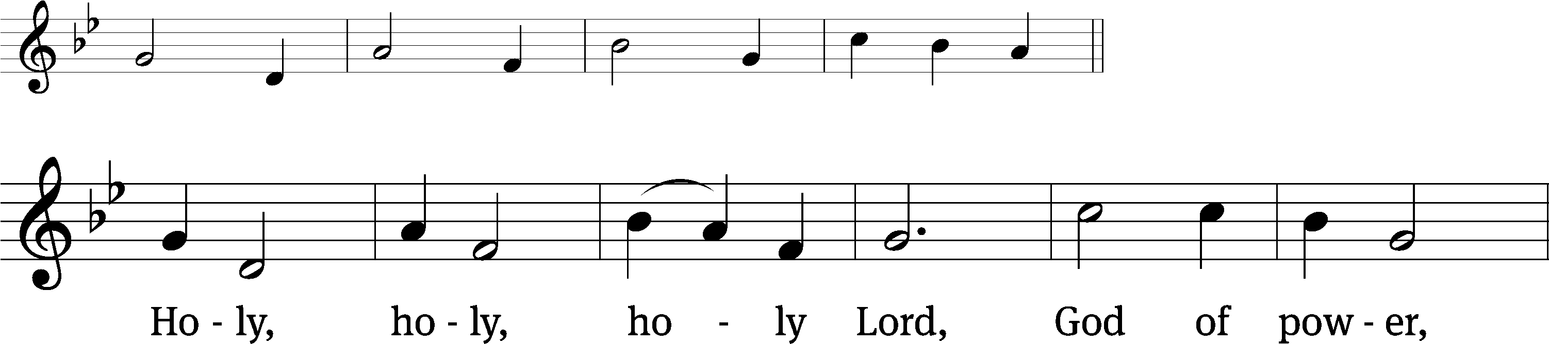

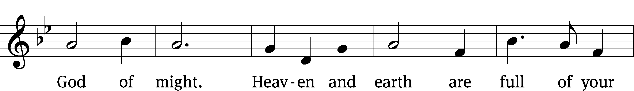

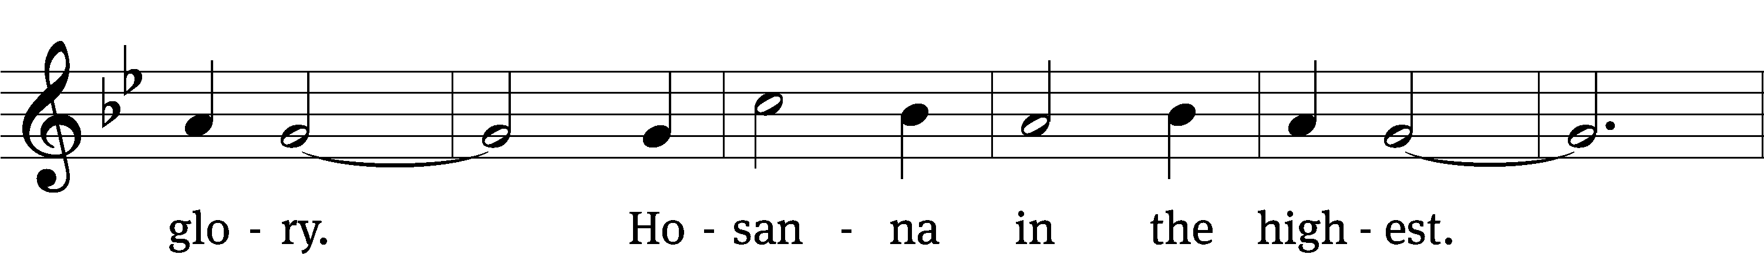

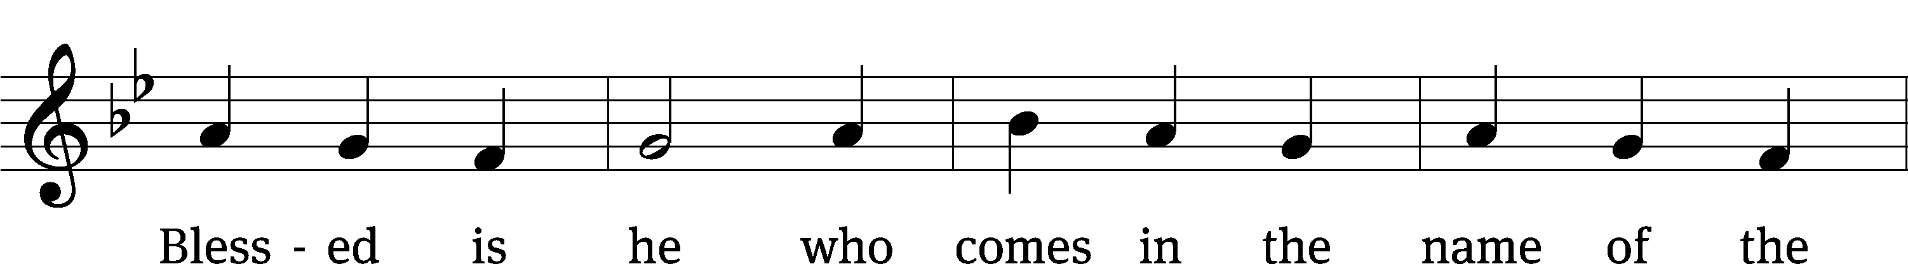

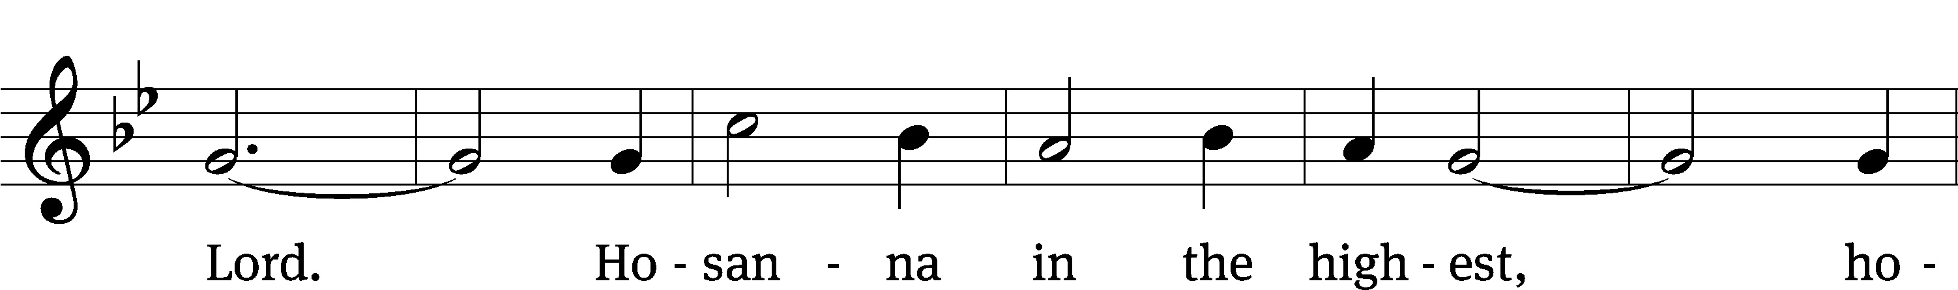

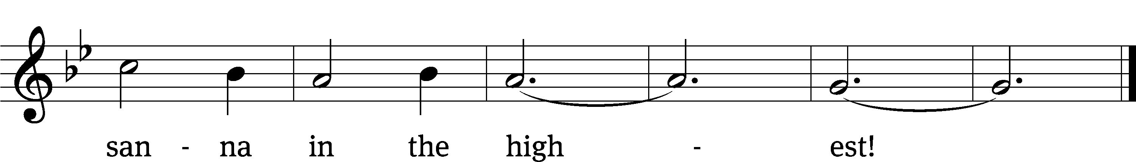

Tune: Marty Haugen  
Tune: © 1984, 1985 GIA Publications, Inc. Used by permission: OneLicense no. 711675

Prayer of Thanksgiving

Lord God, you are worthy to receive thanks and praise from all people. You created the world and all who live in it, and in your mercy you saved us. We give thanks to you for the grace of your Son, Jesus Christ.

Though in very nature God, he took the nature of a servant and became obedient to death, even death on a cross. He offered himself as a sacrifice for sin and redeemed us from its curse and penalty. He rescued us from the terrors of death and restored eternal life with you. He conquered our enemies and gained for us the kingdom of grace and glory.

Bless us as we receive your Son’s body and blood, and lead us to remember his suffering, death, and resurrection. Forgive our sins and fill us with the hope of new life in heaven. Hear our praise and receive our thanks as we worship you—the Father, the Son, and the Holy Spirit.

**Amen.**

Lord’s Prayer

**Our Father, who art in heaven,** **hallowed be thy name,** **thy kingdom come,** **thy will be done** **on earth as it is in heaven.** **Give us this day our daily bread;** **and forgive us our trespasses,** **as we forgive those** **who trespass against us;** **and lead us not into temptation,** **but deliver us from evil.** **For thine is the kingdom** **and the power and the glory** **forever and ever. Amen.**

Words of Institution

Our Lord Jesus Christ, on the night he was betrayed, took bread; and when he had given thanks, he broke it and gave it to his disciples, saying, “Take and eat; this is my 🕇 body, which is given for you. Do this in remembrance of me.”

Then he took the cup, gave thanks, and gave it to them, saying, “Drink from it, all of you; this is my 🕇 blood of the new covenant, which is poured out for you for the forgiveness of sins. Do this, whenever you drink it, in remembrance of me.”

The peace of the Lord be with you always.

**Amen.**

Jesus, Lamb of God CW 186

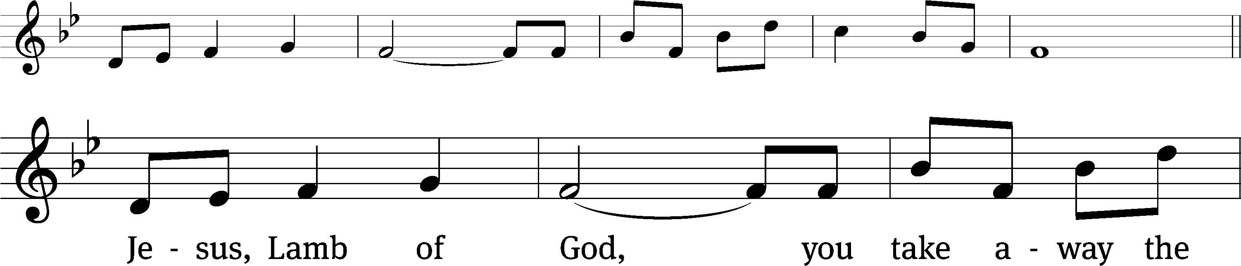

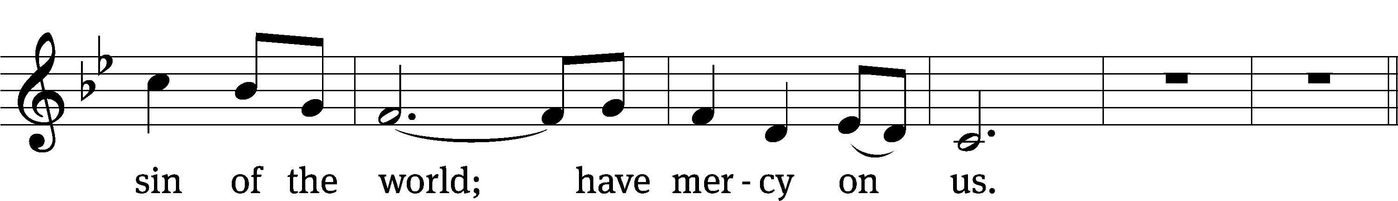

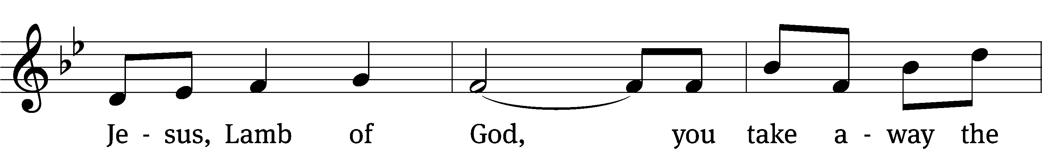

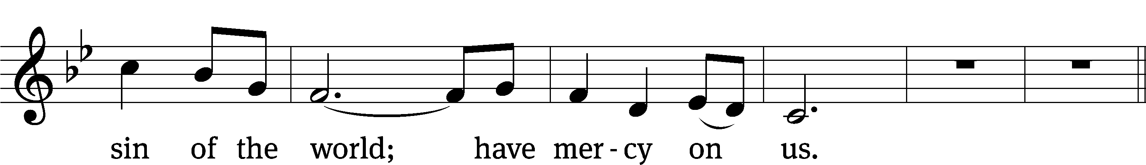

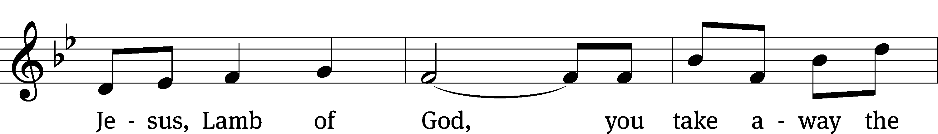

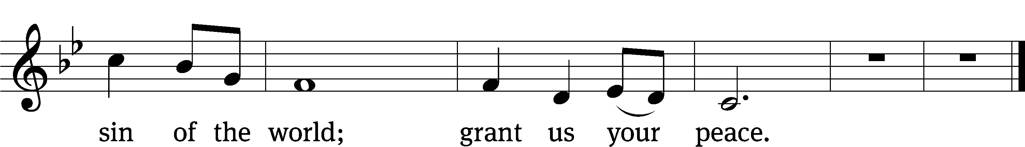

Tune: Marty Haugen  
Tune: © 1984, 1985 GIA Publications, Inc. Used by permission: OneLicense no. 711675

Be seated

A WORD ABOUT THE LORD’S SUPPER:

*The Lord’s Supper is important to us and we celebrate it frequently. Because the Bible has convinced us that Jesus’ body and blood are truly present in this sacrament and that receiving this sacrament together is a public statement of oneness in our beliefs and commitment, we ask our guests to speak with the pastor about establishing communion fellowship with us before communing. We do not want to be presumptuous and place people in the position of stating their agreement with our convictions before we have had an opportunity to explain them. We do look forward to any opportunity to discuss the Christian faith!*

**DISTRIBUTION**

*OF THE*

**LORD’S SUPPER**

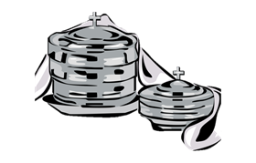

Soul, Adorn Yourself with Gladness CW 663

1 Soul, adorn yourself with gladness;  
leave behind all gloom and sadness.  
 Come into the daylight’s splendor;  
 there with joy your praises render  
unto him whose grace unbounded  
has this wondrous supper founded.  
 He, though reigning high and holy,  
 deigns to dwell with you most lowly.

2 Hasten as a bride to meet him,  
and with loving rev’rence greet him,  
 for with words of life immortal  
 he is knocking at your portal.  
Open wide the gates before him,  
saying, as you there adore him:  
 Grant, Lord, that I now receive you,  
 that I nevermore will leave you.

3 He who craves a precious treasure  
neither cost nor pain will measure,  
 but the priceless gifts of heaven  
 God to us has freely given.  
Though the wealth of earth were proffered,  
naught would buy the gifts here offered:  
 Christ’s true body, for you riven,  
 and his blood, for you once given.

4 Now I kneel before you lowly,  
filled with joy most deep and holy,  
 as with trembling awe and wonder  
 on your mighty work I ponder,  
by such mystery surrounded,  
depths that no one ever sounded.  
 None may dare to pierce unbidden  
 secrets that with you are hidden.

5 Human reason, though it ponders,  
cannot fathom these great wonders,  
 that Christ’s body must be boundless  
 since the souls it feeds are countless,  
and that he his blood is giving  
with the wine we are receiving.  
 These great mysteries unsounded  
 are by God alone expounded.

6 Lord, by love and mercy driven,  
you have left your throne in heaven  
 on the cross for me to languish  
 and to die in bitter anguish,  
to forgo all joy and gladness  
and to shed your blood in sadness.  
 By this blood redeemed and living,  
 Lord, I praise you with thanksgiving.

7 Jesus, sun of life, my splendor,  
Jesus, friend of friends most tender,  
 Jesus, joy of my desiring,  
 fount of life, my soul inspiring:  
at your feet I cry, my maker,  
let me be a fit partaker  
 of this blessèd food from heaven  
 for our good, your glory, given.

8 Jesus, Lord of life in heaven,  
help me when this meal is given  
 to receive it for my blessing  
 as I come, my sins confessing.  
In this supper let me measure,  
Lord, how deep is your love’s treasure,  
 that, as I on earth have eaten,  
 I may be your guest in heaven.

Text: Johann Franck, 1618–1677, abr.; (sts. 1–2, 4, 7): tr. Catherine Winkworth, 1827–1878, alt.; (sts. 3, 5–6): tr. The Lutheran Hymnal, 1941, alt.; (st. 8): tr. Peter M. Prange, b. 1972  
Text (sts. 1–7): Public domain … Text (st. 8): © 2021 Northwestern Publishing House. Used by permission: OneLicense no. 711675

Come, Thou Fount of Every Blessing CW 708

1 Come, thou Fount of ev’ry blessing,  
 tune my heart to sing thy grace;  
streams of mercy, never ceasing,  
 call for songs of loudest praise.  
Teach me some melodious sonnet,  
 sung by flaming tongues above.  
Praise his name, I’m fixed upon it,  
 name of God’s redeeming love.

2 Hitherto thy love has blessed me,  
 thou hast drawn me to this place;  
and I know thy hand will lead me  
 safely home by thy good grace.  
Jesus sought me when a stranger,  
 wand’ring from the fold of God;  
he, to rescue me from danger,  
 bought me with his precious blood.

3 Oh, to grace how great a debtor  
 daily I’m constrained to be!  
Let thy goodness, like a fetter,  
 bind my wand’ring heart to thee:  
prone to wander, Lord, I feel it,  
 prone to leave the God I love;  
here’s my heart, O take and seal it;  
 seal it for thy courts above.

Text: Robert Robinson, 1735–1790, alt.  
Text: Public domain

Stand

Give thanks to the Lord, for he is good;

**his mercy endures forever.**

Whenever we eat this bread and drink this cup,

**we proclaim the Lord’s death until he comes.**

We give you thanks, O Lord, for the foretaste of the heavenly banquet you have given us in this Sacrament. Through this gift you have fed our faith, nourished our hope, and strengthened our love. By your Spirit, help us to live as your holy people until that day when you will receive us as your guests at the wedding supper of the Lamb, who lives and reigns with you and the Holy Spirit, one God, now and forever.

**Amen.**

Blessing

The Lord bless you and keep you.

The Lord make his face shine on you and be gracious to you.

The Lord look on you with favor and 🕇 give you peace.

**Amen.**

O Church, Arise CW 870

1 O Church, arise and put your armor on;  
hear the call of Christ our captain.  
For now the weak

can say that they are strong  
in the strength that God has given.  
With shield of faith and belt of truth  
we’ll stand against the devil’s lies;  
an army bold whose battle cry is love,  
reaching out to those in darkness.

2 Our call to war—to love the captive soul,  
but to rage against the captor;  
and with the sword that makes the wounded whole  
we will fight with faith and valor.  
When faced with trials on ev’ry side,  
we know the outcome is secure,  
and Christ will have the prize for which he died—an inheritance of nations.

3 Come see the cross, where love and mercy meet,  
as the Son of God is stricken;  
then see his foes lie crushed beneath his feet, for the Conqueror has risen!  
And as the stone is rolled away,  
and Christ emerges from the grave,  
this vict’ry march continues till the day  
ev’ry eye and heart shall see him.

4 So Spirit come, put strength in ev’ry stride,  
give grace for ev’ry hurdle,  
that we may run with faith to win the prize  
of a servant good and faithful.  
As saints of old still line the way,  
retelling triumphs of his grace,  
we hear their calls and hunger for the day  
when with Christ we stand in glory.

Text: Stuart Townend, b. 1963; Keith Getty, b. 1974  
Text: © 2005 Thankyou Music, admin. CapitolCMGPublishing,com. Used by permission: OneLicense no. 711675